11253444

Abstract

This reflective report provides information about the IoT based home health monitor, its functionality, security issues and mitigation. In addition, it will describe the commercial and societal implication of the device as well as discuss current trends on IoT and speculated future advancements.

internet of things  
  
602IT

Coursework 2



Contents

LIST OF FIGURES 2

INTRODUCTION 3

PROBLEM 3

SOLUTION 3

IOT DEVICE PURPOSE AND FUNCTIONALITY 3

IOT TECHNOLOGIES AND PROTOCOLS 5

MAX30100 5

DS18B20 8

Arduino Uno R3 8

Node MicroController Unit ESP8266 or NodeMCU 9

ThingSpeak/ ThingView 11

POTENTIAL SECURITY, PRIVACY AND TRUST ISSUES 13

MITIGATING IDENTIFIED SECURITY, PRIVACY AND TRUST ISSUES 13

COMMERICAL, ECONOMIC AND SOCIETAL IMPICATIONS 14

COMMERCIAL 14

ECONOMIC 14

SOCIETAL 14

RECENT TRENDS 14

POTENTIAL FUTURE ADVANCEMENTS 14

CONCLUSION 15

REFERENCES 16

# LIST OF FIGURES

Figure 1 Basic Top view IoT project 4

Figure 2 MAX30100 pulse/oxygen sensor 5

Figure 3 MAX30100 logic diagram 6

Figure 4 IoT project circuit diagram with pin chart done by Author 7

Figure 5 DS18B20 Temperature sensor 8

Figure 6 Arduino UNO R3 9

Figure 7 NodeMCU ESP8266 10

Figure 8 Working image of IoT project 10

Figure 9 NodeMCU(left) receiving and sending data, Arduino output from sensors (right) 11

Figure 10 ThingSpeak result 12

Figure 11 ThingView result 13

# INTRODUCTION

The prevalence of IoT (Internet of Things) in modern times has enhanced society’s quality of life through interconnection, mobility, reduced costs and improved customer experience. It has penetrated multiple sectors thereby providing new opportunities especially in the field of energy, public service and healthcare.

This reflective report will focus in the use of remote health monitors to address the problems in increased hospital admissions.

# PROBLEM

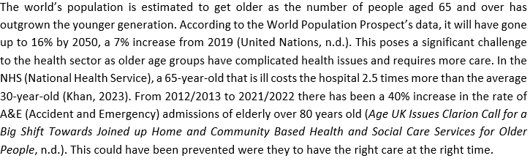

# SOLUTION

Project Description: IoT based patient home health monitoring that is viewable through mobile phone and desktop computer, utilising Arduino UNO R3 and NodeMCU ESP8266 to monitor temperature, heart rate and oxygen saturation.

# IOT DEVICE PURPOSE AND FUNCTIONALITY

The goal of this project is to provide a health monitor that is viewable to both healthcare provider and patient who are in different locations. Studies have shown that by monitoring vitals and clinical symptoms at home can reduce hospital admissions (Dirikgil et al., 2021). As data collected is accessible to both patient and healthcare expert, it allows both parties to take positive measures in treating or preventing any further complications or health issues, thereby promoting proactive and efficient healthcare management.

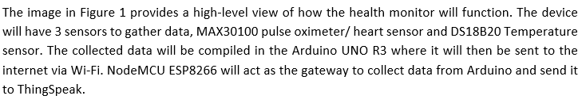

Figure 1 Basic Top view IoT project

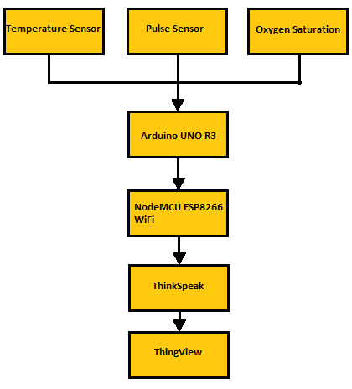

(Image supplied by author)

# IOT TECHNOLOGIES AND PROTOCOLS

## MAX30100

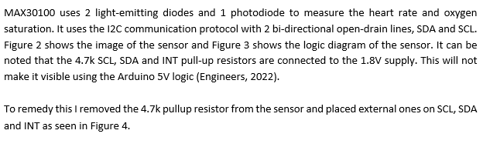

Figure 2 MAX30100 pulse/oxygen sensor

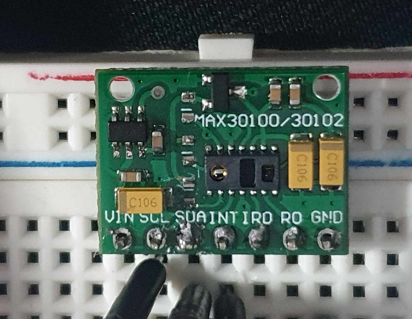

(Image supplied by author)

Figure 3 MAX30100 logic diagram

(Engineers, 2022)

Figure 4 IoT project circuit diagram with pin chart done by Author

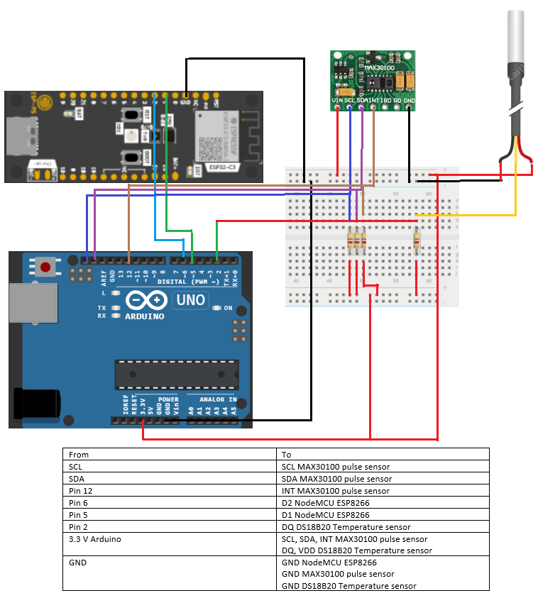

(Image supplied by author)

## DS18B20

DS18B20 is a temperature sensor that uses 1 wire bus for signalling and power. Referring to the image in Figure 5, DQ will be connected to Digital pin 3 of Arduino with a 4.7k pull up resistor in between.

Figure 6 DS18B20 Temperature sensor

(Engineers, 2022)

## Arduino Uno R3

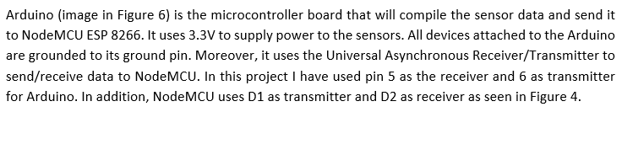

Figure 7 Arduino UNO R3

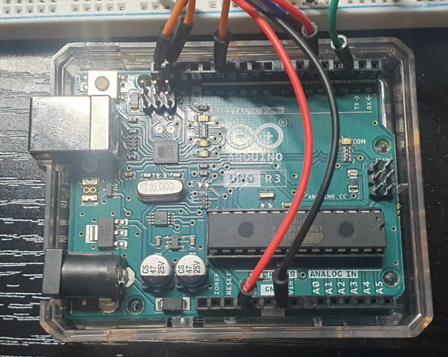

(Image supplied by author)

## Node MicroController Unit ESP8266 or NodeMCU

NodeMCU (image in Figure 7) is an open-source hardware and software development board with WiFi and programming features. In this project, it was used to transmit data from Arduino to ThingSpeak. It uses the Station (STA) mode to connect to existing WiFi/ 802.11 at 2.4 GHz (*NodeMCU ESP8266*, n.d.).

Figure 8 NodeMCU ESP8266

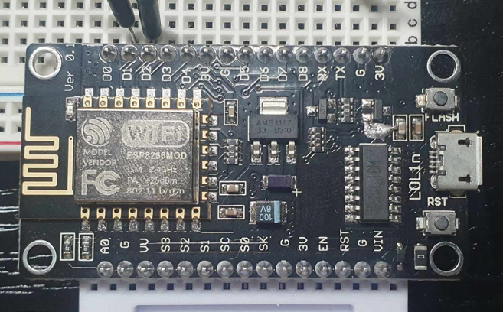

(Image supplied by author)

Figure 8 shows the live image of IoT home monitor all together.

Figure 9 Working image of IoT project

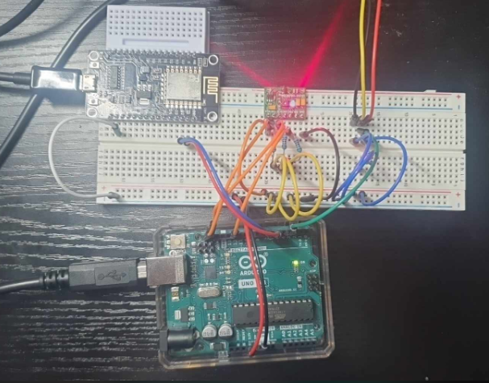

(Image supplied by author)

Figure 9 shows the working project. Arduino receives sensor data and sends it to NodeMCU. NodeMCU receiving data and sending it to ThingSpeak.

Figure 10 NodeMCU(left) receiving and sending data, Arduino output from sensors (right)

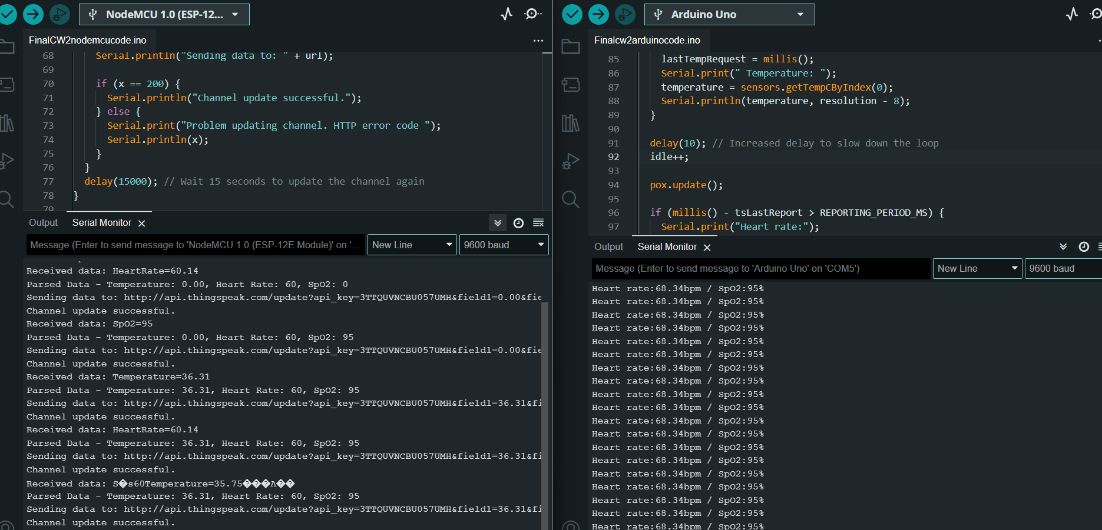

(Image supplied by author)

## ThingSpeak/ ThingView

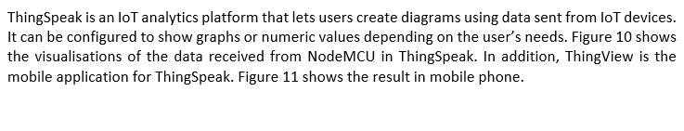

Figure 11 ThingSpeak result

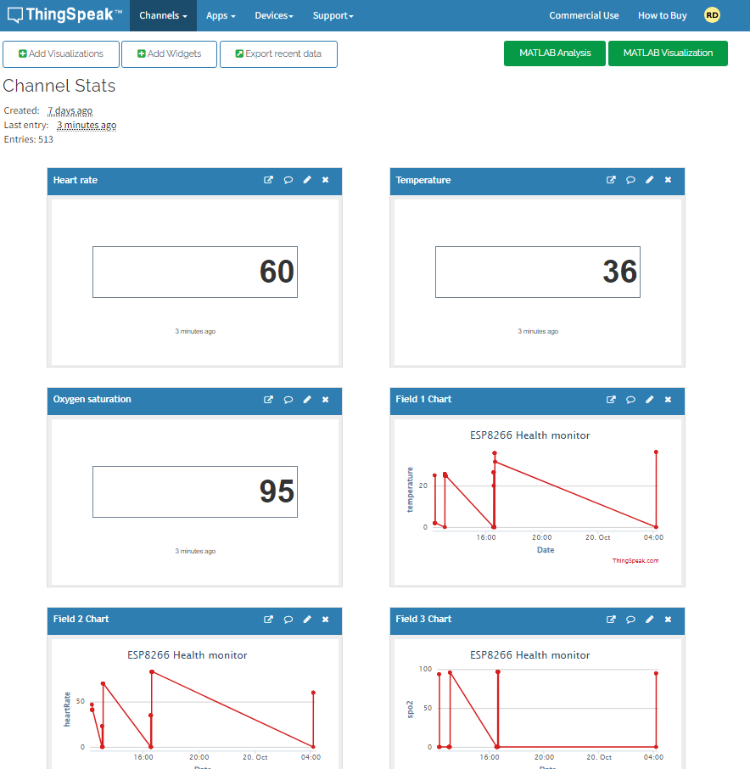

(Image supplied by author)

Figure 12 ThingView result

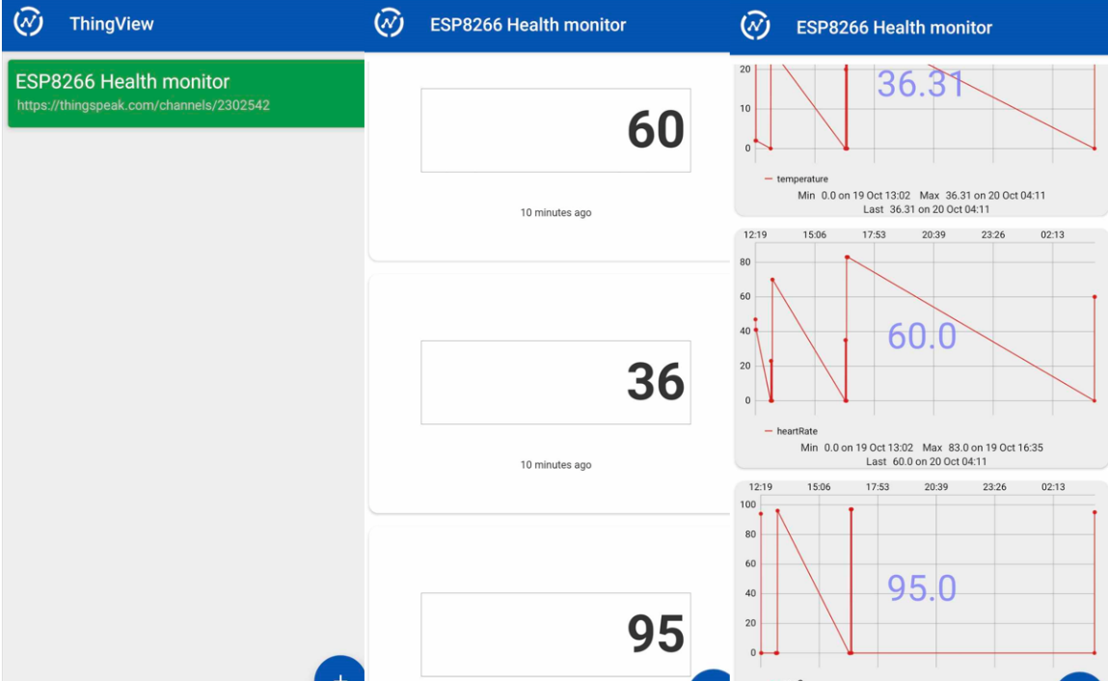

(Image supplied by author)

# POTENTIAL SECURITY, PRIVACY AND TRUST ISSUES

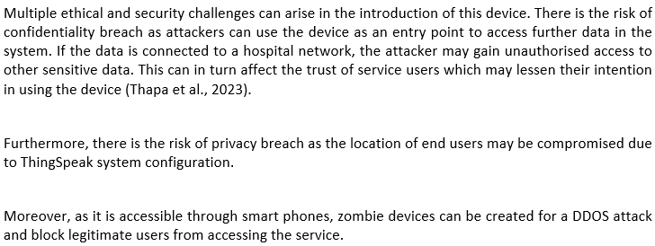

# MITIGATING IDENTIFIED SECURITY, PRIVACY AND TRUST ISSUES

To provide security on the IoT device, data encryption and providing restricted access in the network can be used to alleviate the threats of confidentiality breaches and unauthorised access. Providing authentication mechanisms will also ensure authorised users can only access the device. Introducing secure communication protocols between the device and the internet, such as the MQTT, can limit the surface of attack (Gerodimos et al., 2023).

On the aspect of privacy breach with regards to location, user consent must be acquired as this can be done as a case-by-case basis. Depending on the health of the user, having the location available to the health provider can improve emergency response time as the user is easily located.

Moreover, to prevent DDoS attacks to the IoT network, a distributed architecture approach can be implemented, such as Edge computing (Da Silva et al., 2020). However, this can be become expensive based on per-unit-cost. Furthermore, frequent software updates should be done to fix vulnerabilities.

# COMMERICAL, ECONOMIC AND SOCIETAL IMPICATIONS

## COMMERCIAL

Commercially, this device can revolutionise how the hospital system work. As patients can be monitored at home instead of hospitals, this can decrease the work load and resources of hospitals, allowing them to allocate it on critical cases.

## ECONOMIC

This IoT application can potentially reduce healthcare cost as patients do not take up beds in the hospital anymore. Moreover, this can open a new channel of business that specialises on home healthcare technologies which can possibly improve the economy.

## SOCIETAL

Patients are more empowered through their awareness of their health. This can lead to them proactively taking steps to better their health. Older people will have more autonomy in managing their health which can lead to a better quality of life.

# RECENT TRENDS

The current trends in Health IoT revolves in remote patient monitoring and intelligent hospitals. Utilising the data, the device provides can yield to well-informed strategic plan of care which is tailored to individual patients. In addition, predictive analytics is also a growing trend in healthcare (M. Kumar et al., 2023). This system can gather data from a patient’s past and present medical history to uses machine learning to identify potential outcomes as treatments.

# POTENTIAL FUTURE ADVANCEMENTS

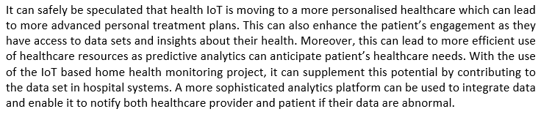

# CONCLUSION

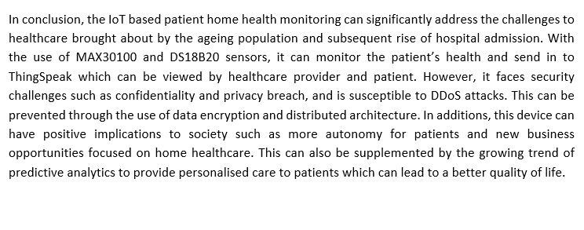

# REFERENCES

*Age UK issues clarion call for a big shift towards joined up home and community based health and social care services for older people*. (n.d.). Age UK. https://www.ageuk.org.uk/latest-press/articles/2023/age-uk-issues-clarion-call-for-a-big-shift-towards-joined-up-home-and-community-based-health-and-social-care-services-for-older-people/#:~:text=In%202021%2F22%20there%20were,care%20at%20the%20right%20time.

Da Silva, F. S. D., Silva, E., Neto, E. P., Lemos, M. O. O., Neto, A., & Esposito, F. (2020). A taxonomy of DDOS attack mitigation approaches featured by SDN technologies in IoT scenarios. *Sensors*, *20*(11), 3078. https://doi.org/10.3390/s20113078

Dirikgil, E., Roos, R., Groeneveld, G. H., Heringhaus, C., Silven, A. V., Petrus, A. H. J., Villalobos-Quesada, M., Tsonaka, R., Van Der Boog, P. J., Rabelink, T. J., Bos, W. J. W., Chavannes, N. H., Atsma, D. E., & Teng, Y. K. O. (2021). Home monitoring reduced short stay admissions in suspected COVID-19 patients: COVID-box project. *The European Respiratory Journal*, *58*(2), 2100636. <https://doi.org/10.1183/13993003.00636-2021>

Engineers, L. M. (2022, May 15). Interfacing MAX30100 Pulse Oximeter and Heart Rate Sensor with Arduino. *Last Minute Engineers*. https://lastminuteengineers.com/max30100-pulse-oximeter-heart-rate-sensor-arduino-tutorial/

Gerodimos, A., Μαγλαράς, Λ., Ferrag, M. A., Ayres, N., & Kantzavelou, I. (2023). IoT: Communication protocols and security threats. *Internet of Things and Cyber-Physical Systems*, *3*, 1–13. https://doi.org/10.1016/j.iotcps.2022.12.003

*IoT Analytics - ThingSpeak Internet of Things*. (n.d.). https://thingspeak.com/

Khan, Z. A. (2023). The Emerging Challenges and Strengths of the National Health Services: A Physician Perspective. *Cureus*. <https://doi.org/10.7759/cureus.38617>

Kumar, M., Kumar, A., Verma, S., Bhattacharya, P., Ghimire, D., Kim, S., & Hosen, A. S. M. S. (2023). Healthcare Internet of Things (H-IoT): current trends, future prospects, applications, challenges, and security issues. *Electronics*, *12*(9), 2050. https://doi.org/10.3390/electronics12092050

Lohachab, A., & Bidhan, K. (2018). Critical Analysis of DDoS—An Emerging Security Threat over IoT Networks. *Journal of Communications and Information Networks*, *3*(3), 57–78. https://doi.org/10.1007/s41650-018-0022-5

*NodeMCU ESP8266*. (n.d.). Arduino Official Store. https://store.arduino.cc/products/nodemcu-esp8266#:~:text=The%20Wi%2DFi%20module%20is,%2F%20PWM)%20and%20PCB%20antenna.

Thapa, S., Bello, A., Maurushat, A., & Farid, F. (2023). Security Risks and User Perception towards Adopting Wearable Internet of Medical Things. *International Journal of Environmental Research and Public Health*, *20*(8), 5519. https://doi.org/10.3390/ijerph20085519

United Nations. (n.d.). *Ageing | United Nations*. https://www.un.org/en/global-issues/ageing#:~:text=Trends%20in%20Population%20Ageing,11%20in%202019%20(9%25).